**Avatar Library**

**Requirements Specification Document**

**Document Version History**

|  |  |  |  |
| --- | --- | --- | --- |
| **Date** | **Version** | **Description** | **Author** |
| 14/02/2016 | 0.1 | Create User Stories | Maxim |
| 14.02.2016 | 0.2 | Create Quality Attributes and Constraints | Murad |
| 05.03.2016 | 0.3 | Updates of User Stories and Quality Attributes. Updates of the SRS content and description | Maxim, Murad |

# **Table of Contents**

2 Introduction

2 .1 Purpose

2 .2 Scope

3 Glossary

4 Product Description

4.1 User roles

4.2 High-level Software Features

4.3 User stories

4.4 Quality attributes

4.5 Software constraints

5 UML with OCL

5.1 UML diagram with OCL

5.2 Descriptions of the OCL constraints

6 SMD

6.1 SMD for each class diagram

6.2 Explanations of SMD

# **Introduction**

**2.1 Purpose**

This document will define the product to be delivered in terms of its functionality, quality

attributes, interfaces and user interface elements. This document will provide a description for the product to be created as well as specific requirements that the final product will meet.

**2.2 Scope**

This document will define The Avatar Library system:

“The application will represent an Avatar person that can persuade householders of modifying their energy consumption habitats by changing the Avatar’s aspect. Thus, the Avatar person can, for instance, adopt a grumpy red face if energy consumption at home surpasses certain threshold during some period of time.

The main goal of this project is to implement visualisation technology for home energy consumption that has positive effects on the attitudes of people at home.”

This document include both the requirements we will implement and the ones we will not. The former are functional requirements described in user stories: US-01, US-02, US-04 and associated non-functional requirements. So that during this project we will create web version of The Avatar Library system that has functionality of turning devices on/off, gathering energy consumption statistics and its visualisation.

# **Glossary**

* The system - The Avatar Library system
* C.U. - energy consumption units
* User - the registered and authenticated user of the system

# **Product Description**

## **User Roles**

|  |  |
| --- | --- |
| **Role** | **Description** |
| **User** | Person who uses the application |

## **High**-L**evel Software Features**

|  |  |
| --- | --- |
| **High Level Software Functionality** | **Associated User Histories (US)** |
| **HL-01** | **US-01 and US-04** |
| **HL-02** | **US-02 and US-03** |

## **User Stories**

|  |  |
| --- | --- |
| **US-01** | **View of consumption** |
| **Description** | As a User, I want see the level of consumption |
| **Acceptance criteria** | * **User can see indicator of consumption in main window always** * **Indicator must change its color if level of consumption has changed. The levels divided on 3 by consumption thresholds:**   + **<200 c.u**   + **200-400 c.u**   + **>400** * **Application must send notification if level of consumption has changed** |
| **Priority** | **High** |
| **Effort** | **Medium** |

|  |  |
| --- | --- |
| **US-02** | **Work with equipment** |
| **Description** | As a User, I want have opportunity to switch on\off all equipment. |
| **Acceptance criteria** | * **I can switch on\off following equipment:**   + **Illumination**   + **Fridge**   + **Computer**   + **Heating**   + **Air conditioner** * **The level of consumption must change according to consumption switched on devices.** |
| **Priority** | **High** |
| **Effort** | **Medium** |

|  |  |
| --- | --- |
| **US-03** | **Work Modes** |
| **Description** | As a User, I want to have different work modes that are improving usability of the Avatar system. Work modes include frequently used actions. |
| **Acceptance criteria** | * **I want to have fast access to work modes** * **I want to have ability to create new work modes** * **I want work mode to be able to use group of devices** * **I want to set time of how long a work mode is active** |
| **Priority** | **Low** |
| **Effort** | **Medium** |

|  |  |
| --- | --- |
| **US-04** | **Statistics** |
| **Description** | As a **User**, I want see statistics for a hour,day,week and month |
| **Acceptance criteria** | * **The statistics for hour must change if User switch on\off any devices** * **The statistics for another time intervals must change according to statistics for hours.** |
| **Priority** | **Medium** |
| **Effort** | **Medium** |

## **Quality Attributes**

|  |  |
| --- | --- |
| **QA-0001** | **Usability** |
| **Description** | **Users will have a high satisfaction with the use of the Avatar software** |
| **Importance** | **High** |
| **Justification** | **Usage has to be user-friendly** |
| **Measure** | **Measured by an Online survey** |

|  |  |
| --- | --- |
| **QA-0002** | **Usability** |
| **Description** | **Switching on/off of any device takes not more than three steps** |
| **Importance** | **Medium** |
| **Justification** | **The user should have fast access to device’s turn on/off menu** |
| **Measure** | **Number of buttons to be pushed from any part of the Avatar system menu** |

|  |  |
| --- | --- |
| **QA-0003** | **Usability** |
| **Description** | **The Avatar system shall have option to set work modes of frequently used actions. Starting a certain work mode takes not more than three steps. It is faster than executing same operations in manual mode.** |
| **Importance** | **Low** |
| **Justification** | **The ability to execute a set of frequently used actions (like switching all the devices off at night, for example) in one click will greatly improve the usability of the system** |
| **Measure** | **The difference in time between executing a set of operations or all operations one by one** |

|  |  |
| --- | --- |
| **QA -0004** | **Usability** |
| **Description** | **The Avatar system shall have option to set scheduler that executes certain operations or work modes at a certain time** |
| **Importance** | **Low** |
| **Justification** | **The ability to schedule executing of certain operations or templates will greatly improve the usability of the system** |
| **Measure** | **Average time saving on the operations executed manually** |

|  |  |
| --- | --- |
| **QA -0005** | **Usability** |
| **Description** | **The Avatar system shall send notifications of consumption level exceeding certain level within 60 seconds after it has changed** |
| **Importance** | **Medium** |
| **Justification** | **Notifications should notify user about high consumption level** |
| **Measure** | **Average time saving on the operations executed manually** |

|  |  |
| --- | --- |
| **QA-0006** | **Updating speed** |
| **Description** | **Changing of the Avatar (indicator) colour after consumption level has been changed takes less than 30 seconds** |
| **Importance** | **Medium** |
| **Justification** | **System must be quickly updated** |
| **Measure** | **Measured by inner testing system and statistics** |

|  |  |
| --- | --- |
| **QA-0007** | **Security** |
| **Description** | **Only users with correct login/password will be given access to the online statistics of consumption level** |
| **Importance** | **Medium** |
| **Justification** | **Only authorized users can get access to the system** |
| **Measure** | **% login attempts with correct/incorrect passwords. Two-factor authorisation** |

|  |  |
| --- | --- |
| **QA-0008** | **Portability** |
| **Description** | **The Avatar system will run on Windows, Linux and Mac OS X platforms** |
| **Importance** | **Medium** |
| **Justification** | **There different types of deices at home.** |
| **Measure** | **% of supported platforms** |

|  |  |
| --- | --- |
| **QA-0009** | **Portability** |
| **Description** | **The Avatar system will run on Android and iOS mobile devices** |
| **Importance** | **Medium** |
| **Justification** | **It is good for users to get access to the system from mobile devices.** |
| **Measure** | **% of supported platforms** |

|  |  |
| --- | --- |
| **QA-0010** | **Extensibility** |
| **Description** | **The Avatar system will be extended to support measuring of energy consumption of other devices** |
| **Importance** | **Medium** |
| **Justification** | **At the beginning the Avatar system has only basic number of devices supported. But each user can have different number of devices consuming energy** |
| **Measure** | **The average person/day to extend the system shall not exceed 10 days** |

|  |  |
| --- | --- |
| **QA-0011** | **Backup** |
| **Description** | **The Avatar system saves statistics to backup drive every hour** |
| **Importance** | **Medium** |
| **Justification** | **System needs to show hours statistic** |
| **Measure** | **% of saved data after failure** |

|  |  |
| --- | --- |
| **QA-0012** | **Reliability** |
| **Description** | **The Avatar system automatically restart after failure in one minute** |
| **Importance** | **High** |
| **Justification** | **System should be reliable** |
| **Measure** | **Number of seconds before the system is restarted** |

|  |  |
| --- | --- |
| **QA-0013** | **Sufficient network bandwidth** |
| **Description** | **The Avatar system do not need very wide network bandwidth. All the data is double saved offline.** |
| **Importance** | **Medium** |
| **Justification** | **System should have low network bandwidth consumption** |
| **Measure** | **% of network bandwidth needed** |

## **Software Constraints**

|  |  |
| --- | --- |
| **CONS-0001** | **Programming language** |
| **Description** | **The system should be implemented in Java or Eiffel programming language** |
| **Importance** | **High** |
| **Justification** | **Customer requirement** |

|  |  |
| --- | --- |
| **CONS-0002** | **Deadline** |
| **Description** | **The system should be implemented before May of 2016** |
| **Importance** | **High** |
| **Justification** | **Customer requirement** |

**5 UML with OCL**

**5.1 UML diagram with OCL**

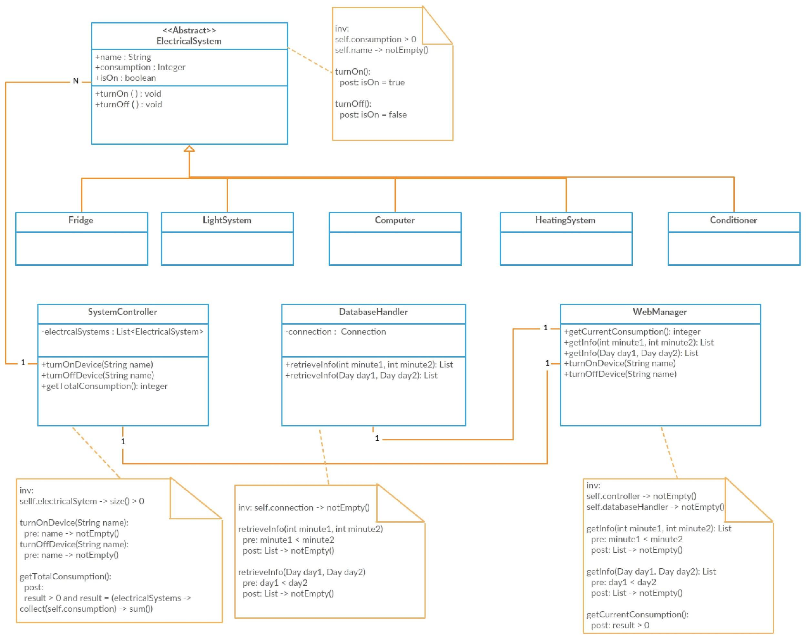

**5.2 Descriptions of the OCL constraints**

**Class ElectricalSystem:**

It is impossible for electrical system to have not positive energy consumption. Also each system has to have name for identification.

**Class SystemController:**

Controller has to control devices (electrical systems), so their existing is required. Controller identify devices name by their names.

**Class DatabaseHandler:**

To operate information (retrieving and saving) handler has to have connection with database. For retrieving information in some time range it is required to go from left bound(smaller number) to right bound(bigger number).

**Class WebManager:**

This class has to know with which database handler and system controller it operates. For retrieving information in some time range it is required to go from left bound(smaller number) to right bound(bigger number). Also system energy consumption can’t be not positive.

6 SMD

6.1 SMD for each class diagram

**ElectricalSystem**

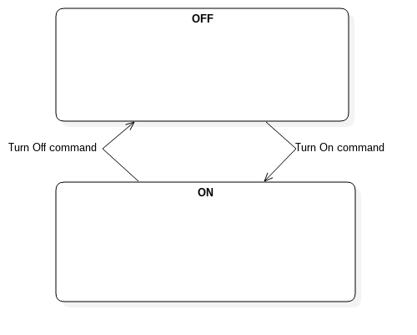

**SystemController**

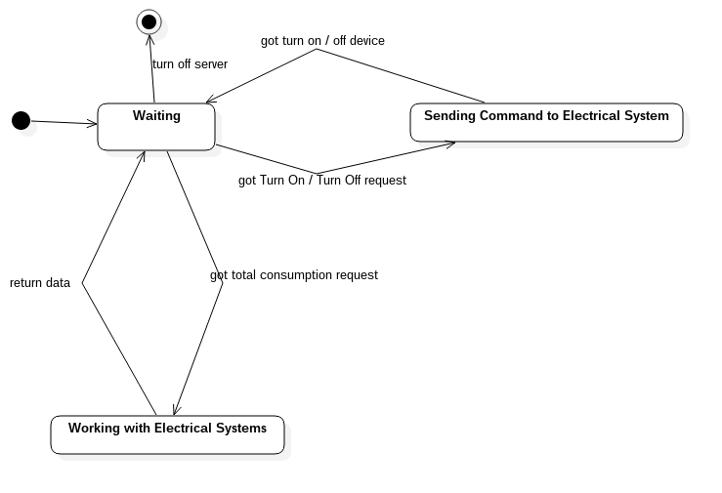

**DatabaseHandler**

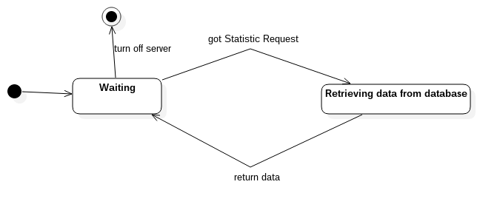

**WebManager**

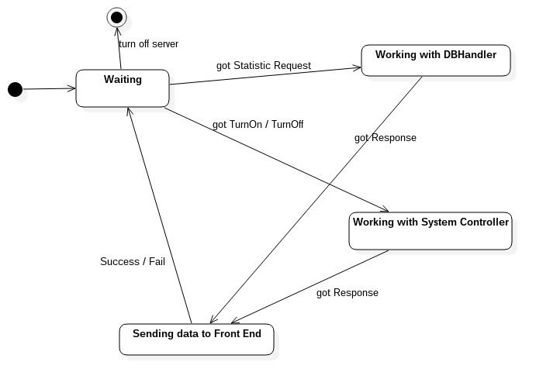

6.2 Explanations of SMD

**Electrical System**

|  |  |
| --- | --- |
| **State** | **Description** |
| ON | The device is ON. |
| OFF | The device is OFF. |

|  |  |
| --- | --- |
| **Stimulus** | **Description** |
| Turn on | The command to turn on the device is sent. |
| Turn off | The command to turn off the device is sent. |

**SystemController**

|  |  |
| --- | --- |
| **State** | **Description** |
| Waiting | The system controller is waiting for the command from the Web Manager. |
| Sending Command to Electrical System | The system contoller is sending command to electrical system to turn on/off the device. |
| Working with Electrical Systems | The system controller is working with Electrical Systems, sending request. |

|  |  |
| --- | --- |
| **Stimulus** | **Description** |
| Got Turn On/Off request | The WebManager has sent the request to turn on/off the device. |
| Got Turn On/Off device | The device in Electrical System has been turn on/off. |
| Got Total Consumption Request | The WebManager has sent the request to have information about the total consumption. |
| Return data | The SystemController has return the data to WebManager. |
| Turn off server | The command to turn off the server is sent. OR the server is off already. |

**DatabaseHandler**

|  |  |
| --- | --- |
| **State** | **Description** |
| Waiting | The DBHandler is waiting for request by WebManager. |
| Retrieving data from database | The DBHandler is retrieving datafrom database after it got request from the WebManager. |

|  |  |
| --- | --- |
| **Stimulus** | **Description** |
| Got Statistic Request | The WebManager has sent statistic request. |
| Return data | The DBHandler has return data to Web Manager. |
| Turn off server | The command to turn off the server is sent. OR the server is off already. |

**WebManager**

|  |  |
| --- | --- |
| **State** | **Description** |
| Waiting | The web manager is waiting for input by user. |
| Working with DBHandler | The web manager is working with the DatabaseHandler after it got the statistic request. |
| Working with System Controller | The web manager is working with the System Controller after it got the command to Turn On/Off the device. |
| Sending data to Front End | The web manager is sending data to Front End after it got response from either DBHandler, or SystemController. |

|  |  |
| --- | --- |
| **Stimulus** | **Description** |
| Got Statistic Request | The user has sent the command to have some info from the database. |
| Got TurnOn/ TurnOff | The user has sent the command to turn on/off the device. |
| Got Response | The web manager has got the response from the DBHandler. |
| Got Response | The web manager has got the response from the SystemController. |
| Success / Fail | The sending data to Front End is succesful/failed. |
| Turn off server | The command to turn off the server is sent. OR the server is off already. |